Group 21 CS346 Report

Explanation of Solutions
Query 1A: Given start_date, end_date, and K, print out the top K stores with lowest revenue (ss_net_paid).

Hadoop solution:
The hadoop solution to this query uses two mapreduce jobs, where the first job is responsible for totalling up the total revenue per store whilst the second job is responsible for sorting the result based on ascending order of total revenue. Below are more detailed explanation of the components in the program:

TokenizerMapper: The mapper for the first mapreduce job that processes every line of the input database file and picks important attributes needed for the remainder of the jobs. There are three main attributes of the database required for this query, namely the date, store ID, and net paid for particular transactions. This mapper stores those three attributes, ignoring any line that has at least one of those values missing, checks if the date is within the given time period in the input (between the start_date and end_date inclusive), and writes out the store ID (key) and net paid (value) to be processed in the combiner or reducer.

Combiner: This is the combiner class that takes in output from a single TokenizerMapper and combines some of the output to reduce the number of input for the reducer of the mapreduce job. The main goal for this combiner is to combine all the output from the given TokenizerMapper that has the same store ID (key) and totalling up the net paid (value) so that every store ID only has one key-value pair to be sent into the reducer for processing. The job of this combiner is similar to the job of the reducer but is responsible for taking input from a single mapper.

FloatSumReducer: This reducer takes in key-value pairs from all TokenizerMapper and/or Combiner (depending on whether the mapreduce job decided to use a combiner) and totals up all the net paid (value) for each store ID (key). Afterwards, the reducer will produce a store ID (key) and total net paid (value) pair to be written into a temporary file that will be the input for the second mapreduce job. After the point of this reducer, there will only be at most one key-value pair per store ID.

SortMapper: This mapper takes in input from the temporary file produced by the first mapreduce job and for every key-value pair in the input, this mapper will switch the positions of the key and value, thus producing a total net revenue (key) and store ID (value) pair. This is done to sort the output based on the total net revenue in ascending order.

TopKReducer: There will only be one TopKReducer in the mapreduce job and the purpose of this reducer is to ensure that it only prints out the first K lines into the output file, where K is a constant integer value determined in the input query, since the input key-value pairs have been naturally sorted in ascending order of the key value.

Hive solution:
The Hive query selects the ‘ss_store_sk’ and gets the total sum of revenue using the SUM() function for each ‘ss_store_sk’ that falls within the specified date range and orders the result by ascending order of the revenue and limits the result by a number K which will output K number of stores with smallest revenue in ascending order.

Query 1B: Given start_date, end_date, M, and N, print out the M least selling items from the N highest selling stores (both in descending order).

Hadoop solution:
The hadoop solution for this query also uses two mapreduce jobs. The first job is responsible for producing a key-value pair of each item in each store with a key of store ID and value that consists of item ID, total item sales, and total sales of all items for the store. For example, a key-value pair of (key: 5, value: 8,4,20) means that it is for store ID 5 that has sold 4 of item ID 8 with a total of 20 item sales. The second mapreduce job is responsible for sorting the result in descending order of total store sales and then followed by total item sales (in descending of the least sold M items). Below are more detailed explanation of the components in the program:

SalesMapper: This mapper simply collects all necessary columns from the input database (date, store ID, item ID, total quantity) and writes out a key of store ID and value of item ID and quantity if the date sold is between the input date period and none of the columns have null values.

SalesReducer: This reducer (also used as a combiner) is responsible for totalling up the total quantity of all items sold in each store. It uses a hashmap to keep track of total quantity sold per item (based on item ID) as it will be needed to be written out later into the temporary file for input of the second mapreduce job. This reducer outputs a key of store ID and value of item ID, total quantity sold (of item), total store sales.

SortMapper: The purpose of this mapper is to take input from the first mapreduce job (through a temporary file) and for each key-value pair, switch the key to be the total store sales in negative and keep the store ID as part of the value instead. For example, an input of (key: 12, value: 3,6,20) will be output as (key: -20, value:3,6,12) as it switches the position of total store sales and store ID and negates the value of total store sales. The negated value of the total store sales (the new key) ensures that output will be sorted in descending order (as the natural sorting system between mapper and reducer is ascending order) for the SortReducer.

SortReducer: This reducer is responsible for printing out the least sold M items from the top N stores (based on total sales). The input for this reducer is based on an equal number of total store sales (all items from the same store will have the same total store sales value). However, in the unlikely event that multiple stores have the exact same value of total store sales, this reducer will be able to differentiate each store using a hashmap (which values are maps of items for the given store ID key). For each store, the reducer then keeps a TreeMap with item ID as key and total quantity sold as value. This TreeMap helps to keep track of the total quantity sold of each item in a given store. Furthermore, the use of a TreeMap helps to ensure items are kept in an ascending order (since Java TreeMap naturally stores in ascending order of key). The last part of this reducer is to ensure it prints out the top M items from the TreeMap in descending order from the first N stores.

Hive solution:
The Hive query is split into five parts with 4 CTE’s used. CTE’s are used to help reduce the same computation being processed.
The first CTE ‘sales_filtered’ takes the store_sales table and gets the records within the specified date range.
The second CTE ‘top_stores’ selects the top N stores with the highest total quantity sold among stores from the ‘sales_filtered’ table.
The third CTE ‘top_items’ selects the most/least M items sold by the top N stores selected from the ‘top_stores’ table.
The fourth CTE ‘store_items’ joins the ‘top_stores’ and ‘top_items’ table ON ‘ss_store_sk’ to get the total quantity sold and top store and items.
The main query selects the ‘ss_store_sk, ss_item_sk, total_quantity’ columns from the ‘store_items’ table. It then creates a temporary table using the ROW_NUMBER() and RANK() functions. The ROW_NUMBER() function is used to help assign a rank to each item within each store based on the total quantity sold. The RANK() function is used to assign a rank to each store based on the total quantity sold. The result is filtered using the WHERE clause to show the top M items within the top N stores. The result is sorted by the store rank in ascending order and then by total quantity sold of each item in descending order.

Query 1C: Given start_date, end_date, and K, print out the top K dates with the highest total of ss_net_paid_inc_tax.

Hadoop solution:
The code written to complete this query is similar to that used in the query for 1A, however there are some differences in the way the data is sorted and ordered in the SortMapper and SecondCombiner Classes and in the choice of objects used to complete the task. Here are the main components of the code:

TokenizerMapper: This class extends ‘Mapper’ class and overrides the map() method to take input records line by line and divides them into attributes using the ‘|’ as a delimiter, then extracts the date and ss_net_paid_inc_tax attributes. Then, solely for those records that are inside the specified date range it writes a key-value pair in which the key is a text representation of the date and the value is the ss_net_paid_inc_tax value.

FirstCombiner: This class extends the ‘Reducer’ class and overrides the reduce() method to total the ss_net_paid_inc_tax for each key value. It also aggregates the values for each key to check that a key has not been encountered before to remove any redundant values.

FloatSumReducer: This class extends the ‘Reducer’ class and overrides its reduce() method to total the ss_net_paid_inc_tax values for each key. This is the final aggregation step and due to the data already being pre-processed by the FirstCombiner and FloatSumReducer classes it is a simple task.

SortMapper: This class extends the ‘Mapper’ class and overrides its map() method to swap the ordering of the key value pairs so that the date becomes the value and the key becomes the ss_net_paid_inc_tax. It then multiplies the ss_net_paid_inc_tax values by -1 so that they can be sorted in descending order.

SecondCombiner: This class swaps the key-value pairs back.

TopKReducer: This class extends the ‘Reducer’ class and overrides its reduce() method to output the top k dates specified when running the query based on the ss_net_paid_inc_tax values.

Hive solution:
The Hive query selects the ‘ss_sold_date_sk’ that the sum of the ‘ss_net_paid_inc_tax’ is the highest in the specified date range. This is done by using the SUM() function on ‘ss_net_paid_inc_tax’. The results are grouped by sold_date_sk to find the total sales in the day and order it based on the highest total sales. The result will be limited by a number K which will output the K number of dates with the highest total value of ‘ss_net_paid_inc_tax’.

Query 2: Given start_date, end_date, and K, print out the top K stores based on total ss_net_paid (from store_sales) and its corresponding floor space (from store) in descending order. Implement both mapper- and reducer-side joins.

Hadoop solution (Reduce side join):
The hadoop solution for this query that uses a reduce-side join runs in two mapreduce jobs. The first job is responsible for joining the store and store sales table and compute the total net sales per store. The result of this job will be the key-value pair of (key: total net paid, value: floor space, total net paid). The second mapreduce job then sorts the output of the first job, first in order of descending total net paid, followed by in ascending order of floor space in case of multiple stores having equal value of total net paid. The second job also ensures that only the top K stores are printed out into the output. Below are more detailed explanation of the components in the program:

StoreMapper: The mapper function for the store table. This mapper reads every line of the table and takes its store ID and floor space value, before outputting it into the JoinReducer. The value of floor space is added with the identifier “FLR” to allow the reducer to identify this value comes from the store table.

StoreSalesMapper: The mapper function for the store sales table. This mapper reads every line of the table and takes its date, store ID, and total net paid. Then it checks if the date falls between the given date range and outputs the store ID and total net paid into JoinReducer if the date falls in between the range (inclusive). THe value of the net paid is added with the identifier “NET” for the reducer to identify that the value is from the store sales table.

JoinReducer: Takes in input from both StoreMapper and StoreSalesMapper and this reducer is responsible for joining the two tables. Each reducer takes input values from the same store ID; one value from the StoreMapper and most likely multiple values from StoreSalesMapper. The reducer then keeps the floor space of the store from the input from StoreMapper (identified by “FLR” identifier in the value) and sum the net paid values from the input from StoreSalesMapper (identified by “NET” identifier in the value). Lastly, the reducer outputs a single key-value pair of (key: total net paid, value: floor space, store ID) for every store ID.

SortMapper: This mapper simply negates the value of the key (total net paid) so that it will be sorted in descending order for the SortReducer by multiplying the key value with -1.

SortReducer: The reducer will receive input in descending order of total net paid (ascending order of its negated value) and its corresponding store ID and floor space of the store. The reducer will have a tree map that helps to store and sort stores in ascending order of floor space in case multiple stores have the same value of total net paid. Lastly, ensuring that at most only K stores are printed out, the reducer will output the key-value pair of (key: total net paid, value: floor space, store ID), ensuring that the final total net paid value printed out is positive (by re-multiplying the negated value with -1). This output will be the top K stores with the highest total net paid and its corresponding floor space and store ID.

Hadoop solution (Map side join):
The hadoop solution for this query that uses a map-side join similarly runs in two mapreduce jobs. The first job has the same responsibility of joining the store and store sales table and compute the total net sales per store, however in this case the joining of the table is done in the mapper instead of the reducer. The reducer for the first job is only responsible for computing the sum value of net paid from the already joined values from the mapper. The result of this job will be the key-value pair of (key: total net paid, value: floor space, total net paid). The second job does exactly the same as the second mapreduce job of the reduce-side join, thus no extra explanation will be written here. Below are more detailed explanation of the components in the first mapreduce program:

JoinMapper: Before any mapper is created, this mapper class will read the store table in its setup process and store the store ID and floor space values of each line of the store table into a hashmap that will be accessible for all the mappers. The mapper function itself reads from the store sales table and for every line, it checks that the date, store ID, and net paid values are not null and if the date is between the given date range, the mapper will write out the key-value pair of (key: store ID, value: floor space, net paid). Note that the output from the mapper is already the joined value from the two tables (both floor space and net paid in the same key-value pair.

StoreReducer: Takes in input from the JoinMapper. Each reducer will take input values that correspond to the same store ID (key) value. The main job of this reducer is to compute the sum of net paid from all the given input values (as they all come from the same store) and write out the key-value pair of (key: total net paid, value: floor space, store ID).

The second mapreduce job’s components (SortMapper and SortReducer) are implemented in the same way and serve the same purpose as the ones used in the reduce-side join solution. Further explanation to these two components can be read in the explanation to the reduce-side join solution of Query 2.

Hive solution:
The Hive query selects the ‘s_store_sk’ and ‘s_floor_space’ and the sum of the ‘ss_net_paid’ using the SUM() function. This is done by joining records from ‘store_sales’ and ‘store’ table on ‘s_store_sk’ and ‘ss_store_sk’ within the specified data range and grouping it by ‘s_store_sk’ and ‘s_floor_space’. The result will be limited by a number K and the output will be ordered by the highest ‘ss_net_paid’ first and if there are ties it will be ordered using ‘s_floor_space’ instead.

General Design Choices for Hadoop solutions:
- DoubleWritable is used for storing total net revenue as they provide the highest precision and can store the largest values.
- The sorting of the output relies on the natural sorting algorithms used between mappers and reducers in ascending order of the key values. Multiplying the key values by -1 is sometimes used to make the sorting in descending order as required by some of the query.
- Combiners are used in some solutions to reduce the output produced by each mapper into the necessary reducers, optimising the mapreduce job when required.
- For map-side join, the store table is chosen to be the one cached as it is the much smaller table that can easily fit into memory.

Exploratory Data Analysis
Exploratory Data Analysis (EDA) is a vital step in understanding the underlying structure, trends, and patterns within a dataset. In this report, we will analyse the store_sales_40G and store_40G datasets to uncover valuable insights that can inform the company's marketing, operations, staffing, and database management decisions, greatly enhancing database performance and efficiency.

1) Seasonal Trends
The seasonal trend analysis showed that sales are heavily concentrated during the holiday season, particularly in November and December. This finding is consistent with the well-documented phenomenon of increased consumer spending during the holiday season (The Guardian, 2023). Figure 1 shows a clear spike in sales from July to August as this is the period when people tend to go on holidays (keyzapp, 2016). Furthermore, the sales peak during the months of November and December (sensormatic, 2022) particularly on Black Friday and the day before Christmas.
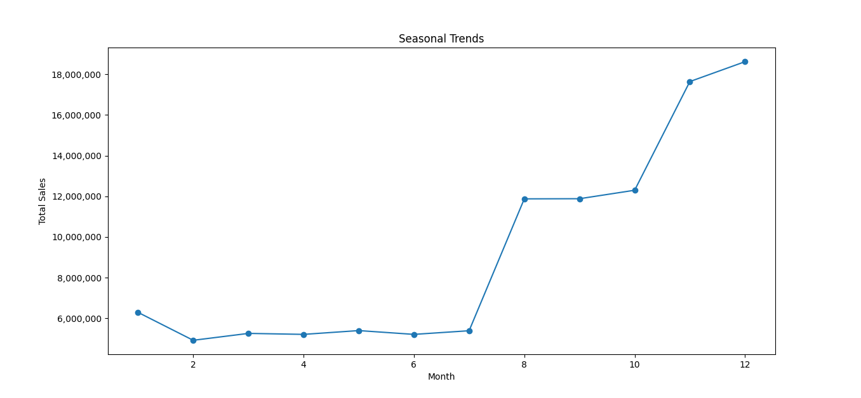
The company can benefit from knowing how sales change throughout the year. When sales are high, especially during the holiday season, the company can spend more on marketing and stock up on popular products. This way, the company can take advantage of the high consumer demand and avoid running out of products. When sales are low, especially from February to July, the company can get rid of excess inventory by offering discounts or other incentives. The company can also try to boost sales during these months by creating special offers or events. Seasonal trends also affect how well the database works. The company can expect more database usage when sales are high and plan ahead for it. This can help prevent database problems and make sure that the database can handle the high demand during the busy season.
Additionally, the EDA insights can inform better database maintenance and optimization strategies. For instance, the company can schedule database maintenance tasks, such as index rebuilds and data backups, during the low-sales months to minimise the impact on database performance during peak sales periods.
2) Sales by Day of the Week
Another critical aspect of the EDA is the analysis of sales by day of the week. Figure 2 illustrates the distribution of sales for each day, with Wednesday showing the highest sales volume. According to a study by Inc. (2014), this observed pattern of sales volume could be attributed to various factors, such as consumer shopping habits, marketing efforts, and store promotions.

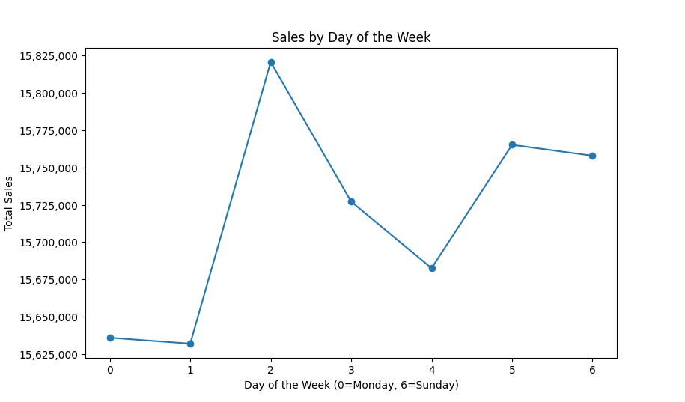
The store_sales_40g dataset may not show how retail sales usually change. It may only show how sales change for a specific company or type of product. For example, the company may have special deals or events on Wednesdays that make more people buy their products. The store_sales_40g dataset may also be influenced by things that happen outside the company, such as local events or holidays that make people shop more or less. To find out why the sales data looks the way it does, more research and analysis are needed. The company could ask their customers why and when they shop at their store or look at other data sources such as social media activity.
Understanding sales patterns by the day of the week can help companies allocate resources more effectively, improve customer service, and optimise database management. By understanding which days are the busiest, companies can schedule more staff on high-sales days and less staff on low-sales days. This can help reduce wait times and improve customer satisfaction. From a database perspective, understanding daily sales patterns can help companies plan for increased database usage and potential bottlenecks on those days in order to ensure a smooth shopping experience for the customers.

Performance Analysis (Hadoop vs Hive)

Use of Combiners (Hadoop):
The main purpose of combiners is to reduce the volume of data that needs to be transferred over the network between ‘mappers’ and ‘reducers’ which has the potential to increase performance when there is a large volume of ‘intermediate’ data that needs to be sorted. Combiners do this by performing a partial aggregation of data before it is inputted into the reducer.

Completing this query for the large data set used for the coursework involved the mappers generating a large amount of intermediate data, had we not used combiners the entirety of this intermediate data would have been sent to the reducers and would require more disk operations and CPU usage by the reducers leading to worse performance.

In some cases, when partial aggregation of data before being sent to a reducer has a higher computational cost than not performing this aggregation, combiners can make performance worse.

Performance Metrics:
To analyse the performance of the Hadoop vs Hive frameworks we used the following metrics:

Query Execution Time (Actual time): This refers to the time taken by the system to execute the query. Execution time can be influenced by a number of factors such as the complexity of a query, resources available and the size of the data set. If the query execution time using one framework is better than using another this indicates that the first framework is more efficient at executing the query.

CPU Time Spent: This refers to the amount of time the CPU spends on the execution of the query. A high CPU usage time indicates that the query requires a lot of CPU resources and in some cases this could lead to the execution time of a query being bound by the CPU.

Query | Query Execution Time (Actual time) | CPU Time Spent
1A Hive | 6 minutes 18 seconds | 8 minutes 37 seconds
1A Hadoop | 6 minutes 38 seconds | 14 minutes 34 seconds
1B Hive | 14 minutes 40 seconds | 22 minutes 50 seconds
1B Hadoop | 9 minutes 35 seconds | 20 minutes 20 seconds
1C Hive | 6 minutes 23 seconds | 9 minutes 36 seconds
1C Hadoop | 6 minutes 49 seconds | 15 min 48 seconds
2 Hive | 7 minutes 30 seconds | 11 minutes 4 seconds
2 Hadoop - Memory-Backed Join | 6 minutes 55 seconds | 17 minutes 14 seconds
2 Hadoop - Reduce-Side Join | 8 minutes 23 seconds | 16 minutes 36 seconds
Table 1. Hadoop and Hive Comparison Table

Each framework was tested on the 40G Table using the same input values for a fair comparison. The input values for the date ranges are from 2450816 and 2452642 (start and end dates), K = 5, M = 7, N = 5.

The results displayed in the table show that Hive performs better than Hadoop for queries 1A and 1C, but performs worse for query 1B. This suggests that Hadoop performs better in instances where queries are more complex and are harder to express in SQL which can be seen by comparing the length and complexity of the Hive solutions.

How does changing the input parameters affect performance?
Query and Metric | Start: 2450816  End: 2452642  K:5, M: 7, N: 5 | Start: 2450900  End: 2451900  K: 5, M: 7, N: 5 | Start: 2450900  End: 2451400  K: 5, M: 7, N: 5 | Start: 2450900  End: 2451400  K: 10, M: 15, N: 10 | Start: 2450900  End: 2451400  K: 50, M: 25, N: 20
1A CPU Time Spent | 14 minutes 34 seconds | 14 minutes 10 seconds | 13 minutes 38 seconds | 13 minutes 35 seconds | 13 minutes 33 seconds
1A Time spent by map tasks | 29 minutes 51 seconds | 28 minutes 38 seconds | 27 minutes 34 seconds | 27 minutes 54 seconds | 27 minutes 16 seconds
1A Time spent by reduce tasks | 4 minutes 53 seconds | 4 minutes 22 seconds | 4 minutes 35 seconds | 4 minutes 15 seconds | 4 minutes 32 seconds
1B CPU Time Spent | 20 minutes 20 seconds | 17 minutes 57 seconds | 15 minutes 32 seconds | 15 minutes 43 seconds | 15 minutes 40 seconds
1B Time spent by map tasks | 34 minutes 35 seconds | 32 minutes 3 seconds | 29 minutes 25 seconds | 30 minutes 8 seconds | 29 minutes 35 seconds
1B Time spent by reduce tasks | 7 minutes 14 seconds | 6 minutes 14 seconds | 5 minutes 17 seconds | 5 minutes 9 seconds | 5 minutes 20 seconds
1C CPU Time Spent | 15 minutes 48 seconds | 14 minutes 41 seconds | 14 minutes 0 seconds | 13 minutes 59 seconds | 13 minutes 52 seconds
1C Time spent by map tasks | 30 minutes 58 seconds | 29 minutes 37 seconds | 29 minutes 35 seconds | 31 minutes 31 seconds | 28 minutes 32 seconds
1C Time spent by reduce tasks | 5 minutes 10 seconds | 5 minutes 1 second | 5 minutes 2 seconds | 4 minutes 56 seconds | 4 minutes 44 seconds
2 CPU Time Spent  Map Join | 17 minutes 14 seconds | 15 minutes 40 seconds | 14 minutes 18 seconds | 14 minutes 32 seconds | 14 minutes 19 seconds
2 Time spent by map tasks  Map Join | 31 minutes 55 seconds | 30 minutes 24 seconds | 28 minutes 6 seconds | 29 minutes 58 seconds | 28 minutes 4 seconds
2 Time spent by reduce tasks  Map Join | 6 minutes 11 seconds | 5 minutes 22 seconds | 4 minutes 57 seconds | 4 minutes 58 seconds | 4 minutes 59 seconds
2 CPU Time Spent  Reduce Join | 16 minutes 36 seconds | 14 minutes 56 seconds | 14 minutes 0 seconds | 14 minutes 1 second | 13 minutes 54 seconds
2 Time spent by map tasks  Reduce Join | 29 minutes 56 seconds | 28 minutes 5 seconds | 28 minutes 14 seconds | 28 minutes 13 seconds | 28 minutes 3 seconds
2 Time spent by reduce tasks  Reduce Join | 6 minutes 16 seconds | 5 minutes 33 seconds | 4 minutes 46 seconds | 4 minutes 47 seconds | 4 minutes 43 seconds
Table 2. Hadoop Performance Comparison Using Different Input Parameters

This table is used to evaluate how performance changes when the input parameters are changed. These metrics were chosen as they directly measure the amount of time it took for a MapReduce to finish processing tasks.

This table shows that reducing the range of the dates searched, reduces the CPU time spent, time taken by map tasks and time spent by reducing tasks indicating an improvement in performance. This is likely because in the Hadoop programs, the records are first filtered by start and end dates, and if they do not fall within the inputted time frame then no further processing is done. Thus, larger input date range would mean that more data will have to be processed, slowing down performance.

Furthermore, the performance metrics do not indicate that changing the values of K, M or N have a significant impact on performance as these values simply change the number of output lines whilst the number of data needed to be processed remains the same. One reason for this is also because it is not good practice to just end the mapreduce job after a certain line of output is produced as there can be many reducers running in parallel and ending the program prematurely may cause issues to arise.

Another observation seen from Table 1. is that although the map-side and reduce-side takes similar CPU running time, a mapreduce job using map-side join takes significantly shorter query execution time (about 17% less time) as compared to mapreduce job using reduce-side join.

Conclusion (Best Framework)
Scenarios where Hadoop performs better than Hive:
- Large-scale batch processing - processing large data sets in batch mode and is highly scalable and fault-tolerant
- High availability - withstand failures and automatically replicate data across multiple nodes/buckets to ensure data availability.
- Unstructured data - data which do not fit into a traditional relational database
- Custom data processing - write custom processing logic, which can be optimised for specific use cases

Scenarios where Hive performed better than Hadoop:
- Interactive querying and analysis of structured data - get quick responses
- Ad-hoc querying - write SQL-like queries on top of Hadoop
- Data warehousing - allow users to store and query large volumes of structured and semi-structured data
- Analytics - built-in functions and operators that can be used for data analytics
- Integration with other tools - allow user to build end-to-end data processing pipelines using a variety of tools

Upfront investment for using MapReduce is small as there is no need to use schemas, no integrity constraints, no data cleaning, no normalisation and NoSQL. Almost any user with minimal knowledge of Java is able to write and run Hadoop jobs making it popular among non-database users (Dittrich, Richter and Schuh, 2013).

Hive provides some performance optimization techniques such as partitioning, bucketing and indexing to improve query performance. Hive is much faster when performing basic operations, such as various selections or doing various data manipulations like random data sampling and statistics (Network World, 2012).

In conclusion, Hadoop and Hive are powerful tools in the big data ecosystem and serve different purposes. Hadoop is best suited for scenarios where data needs to be stored and processed at scale. As the entire system design is centred around the idea of executing long running jobs (Dittrich, Richter and Schuh, 2013) and Hive is a good choice for scenarios where data analysts are more comfortable with SQL-based querying and analysis so they can leverage the power of Hadoop without needing to learn new programming languages.

For this task we concluded that Hadoop would be the better framework. Although Hive may perform better for some simplistic queries, in industry queries they are likely to be complex, Hadoop would perform better on large batches of data such as the one used for this coursework and there would be no need for the creation of a schema, hence providing a better framework.

References
- Partington , R. (2023) Christmas and World Cup help UK retail sales rise in December, The Guardian. Guardian News and Media. Available at: https://www.theguardian.com/business/2023/jan/10/christmas-and-world-cup-help-uk-retail-sales-rise-in-december
- Hill, T. (2016) Combating the august myth: It's anything but a quiet month, Keyzapp. Available at: https://www.keyzapp.com/combating-august-myth-anything-quiet-month
- Messina, J. (2022) 2022 global top busiest days, Sensormatic. Available at: https://www.sensormatic.com/resources/pr/2022/2022-global-top-busiest-days
- Winfrey, G. (2014) The best day to close a sale (infographic) | inc.com, Inc.com. Inc. Available at: https://www.inc.com/graham-winfrey/the-best-days-of-the-week-for-generating-sales.html
- Dittrich, J., Richter, S. and Schuh, S. (2013). Efficient OR Hadoop: Why Not Both? Datenbank-Spektrum, 13(1), pp.17–22.
- Hadoop on Windows Azure: Hive vs. JavaScript for processing big data. 2012. Network World (Online), .

